**Part 1: MongoDB Database Getting Started**

1. Download MongoDB Compass <https://www.mongodb.com/try/download/compass>

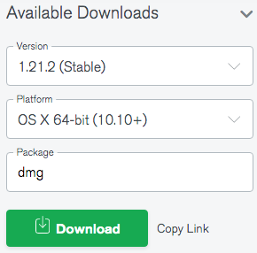

Make sure you are downloading the **latest (Stable) version of Compass**.

1. Install Compass on your computer.
2. Start Compass.  
     
   Graphical user interface, text, application, Word

   Description automatically generated
3. When Compass opens you will see a form titled "New Connection".
4. Click on the link “Fill in connection fields individually”

1. Use the following information and the two tabs in the New Connection window to complete this form, but do not click "Connect" yet.

**Hostname:** cluster0-shard-00-00-jxeqq.mongodb.net

**Username:** m001-student

**Password:** m001-mongodb-basics

**Replica Set Name:** Cluster0-shard-0

**Read Preference:** Primary Preferred

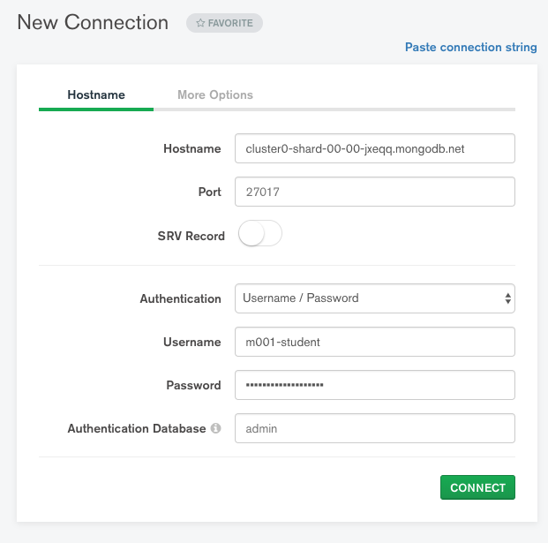

Use the More Options tab and fill-in additional fields as below:

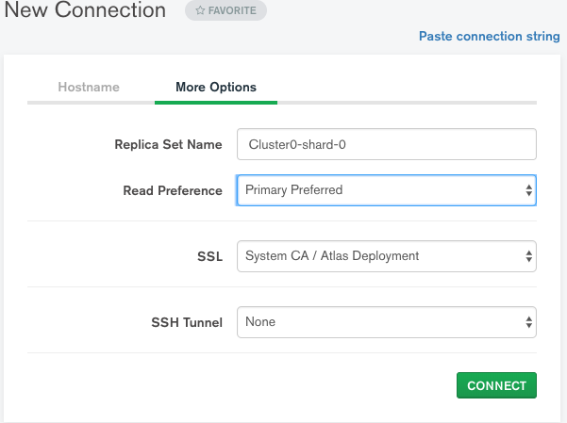

1. Click on the "Favorites" button and enter some **Favorite Name**. Doing so will enable you to easily connect to MongoDB online server next time without entering all the above information.



1. Now, click the "Connect" button. You’ll be connected to an online MongoDB database server and will see that some example databases are currently available:

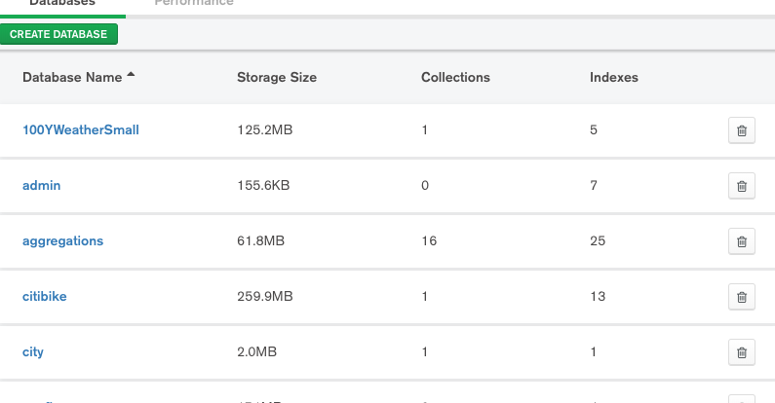

Part 2: **Homework #5 Instructions**

* Log into online MongoDB Atlas account (see instructions above)
* Write a MongoDB query in MongoDB Compass to display the following information from the movies collection in the *mflix* database:

Show all documents for movies produced in 2019 such that either their genre is documentary, or they are in Spanish language.

Partial output is shown below.

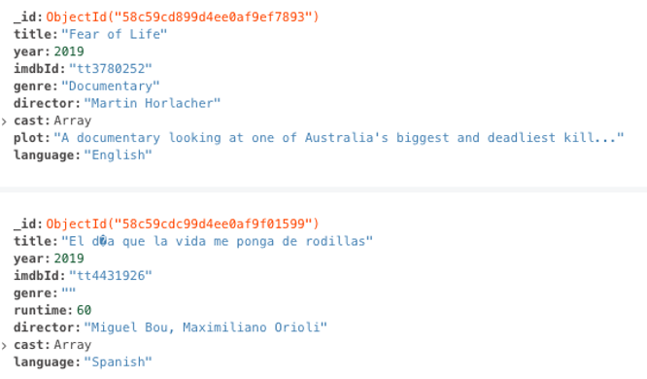

Create a screenshot of your complete query and its complete output in a single screenshot, paste it into a Word document. Write your full name at the top of the document and submit. Upload the completed homework ( a Word document) to Canvas.